Ian Camire

Sed Lab

1. Sed s/Jo/Josephine/ SedLab

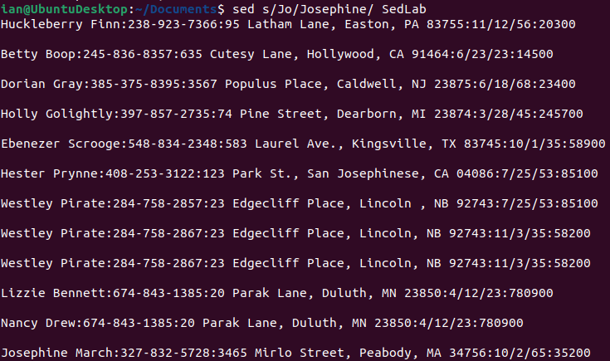

1. Sed “$(($(wc -l <SedLab)-8 )),$ d” SedLab

Baeldung.com Remove the Last n lines from a file in Linux

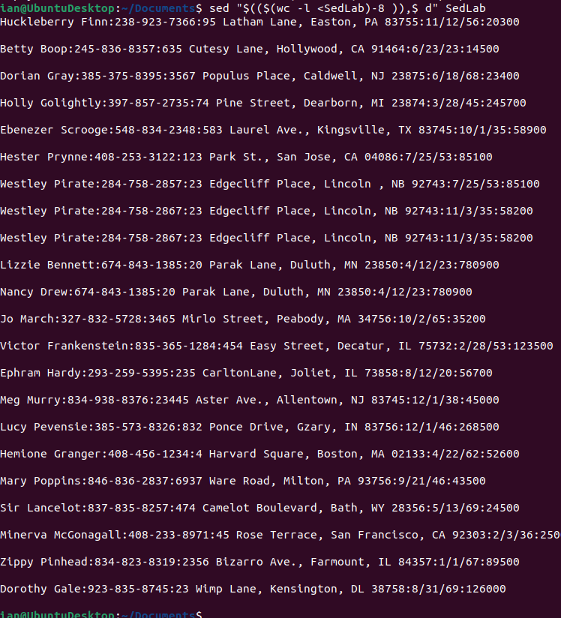

1. Sed -n “3,15p;” SedLab

The -n indicates that automatic printing of lines is disables except for the numbers within the quotation marks. The numbers in the quotation marks tells the system that I want lines 3 through 15 to be printed (indicated by the p).

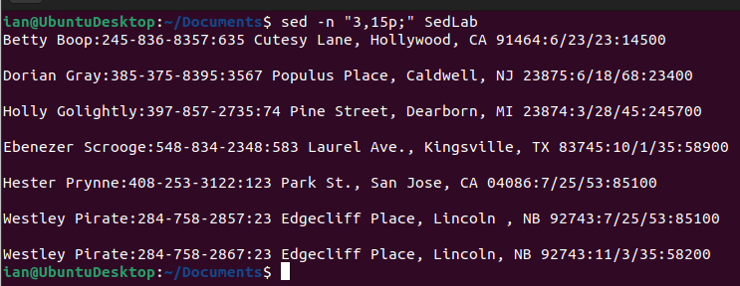

1. Sed ‘/CA/d’ SedLab

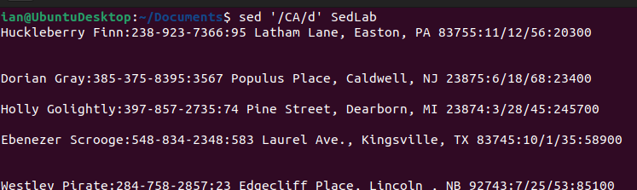

1. Sed -n ‘/[0-9]\*\/[0-7]\/[0-9]\*/ p’ SedLab

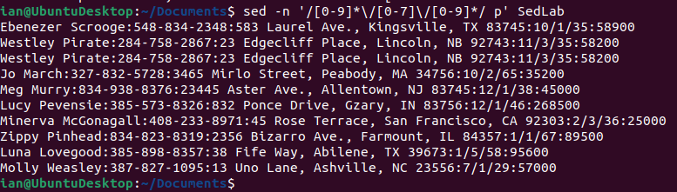

1. Sed ‘/^Sir/s/$/ \*\*\*/’ SedLab

StackOverflow.com by Paxdiablo

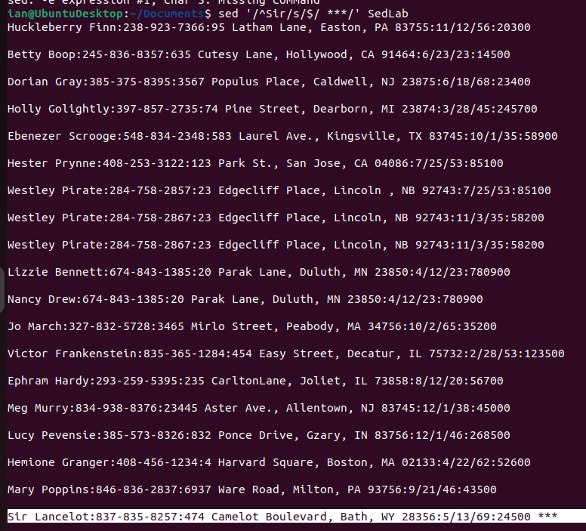

1. Sed “s/Westley Pirate.\*/As you wish/g” SedLab

